SAMPLE SCREENSHOT OF POWER BI ANIMATION

Screenshot of Scatter Chart

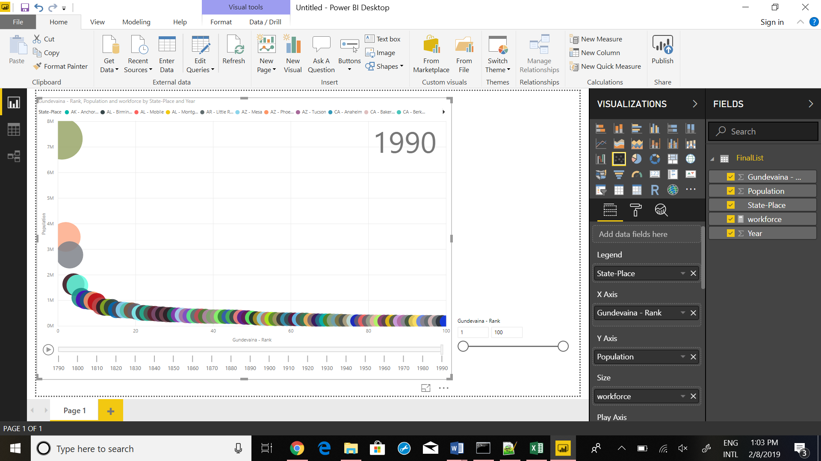

Screenshot of top5 with category label on

